Database Health care Management Project

NAME : MALIK IATAZAZ ALTAF

REG NO :21PWBCS0863

SECTON :B

COURSE : DATABASE MANAGEMENT SYSTEM

INSTRUCTOR:SIR SADIQ U-REHMAN

# Patient Table

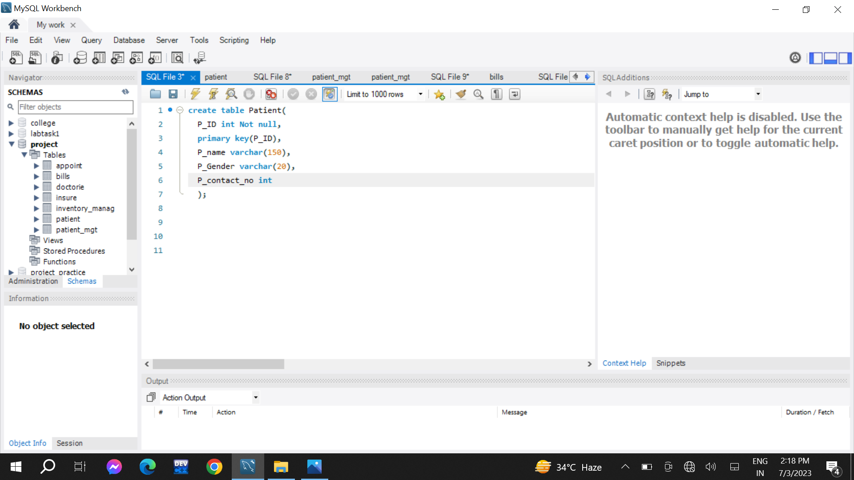

# Patient management Table

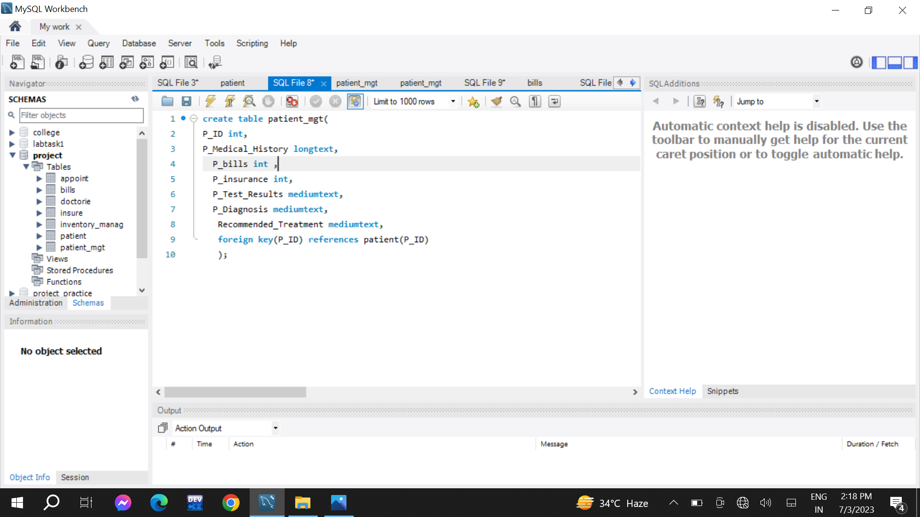

# Bills Table

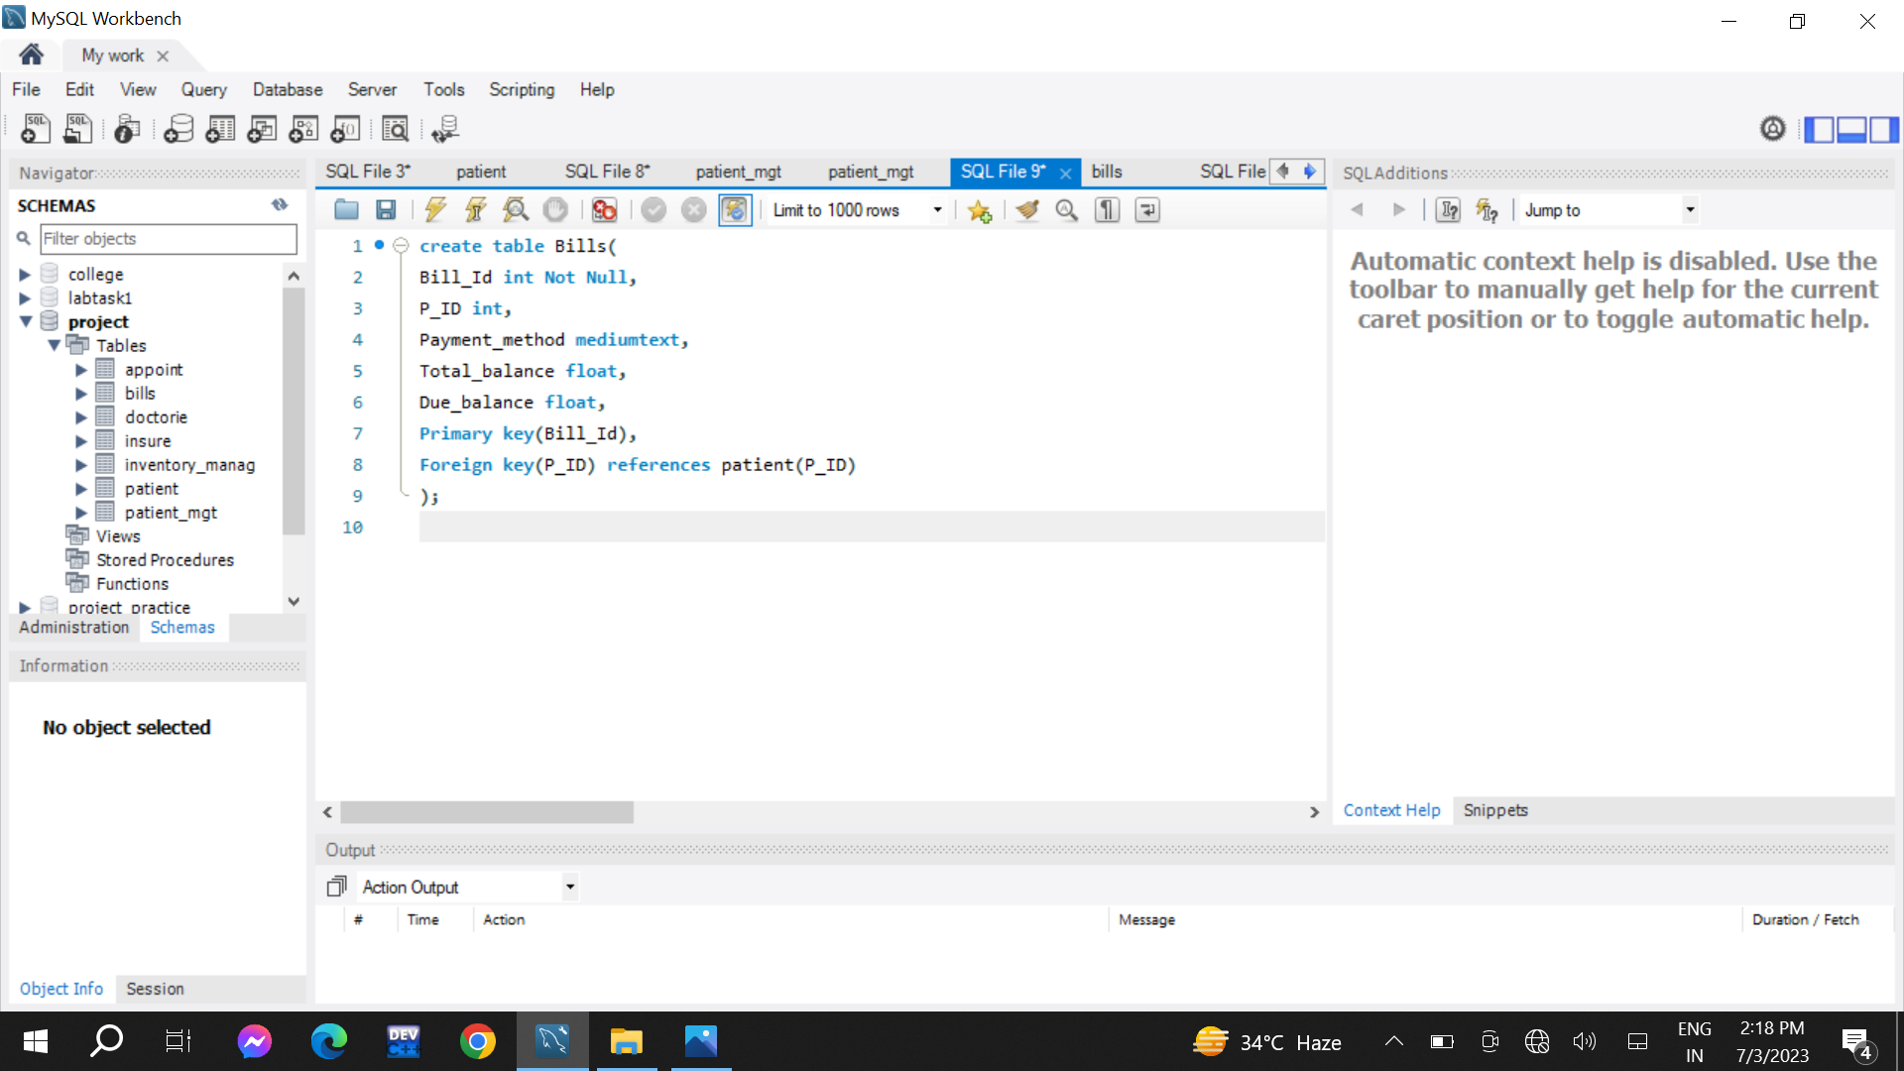

Insurance Table

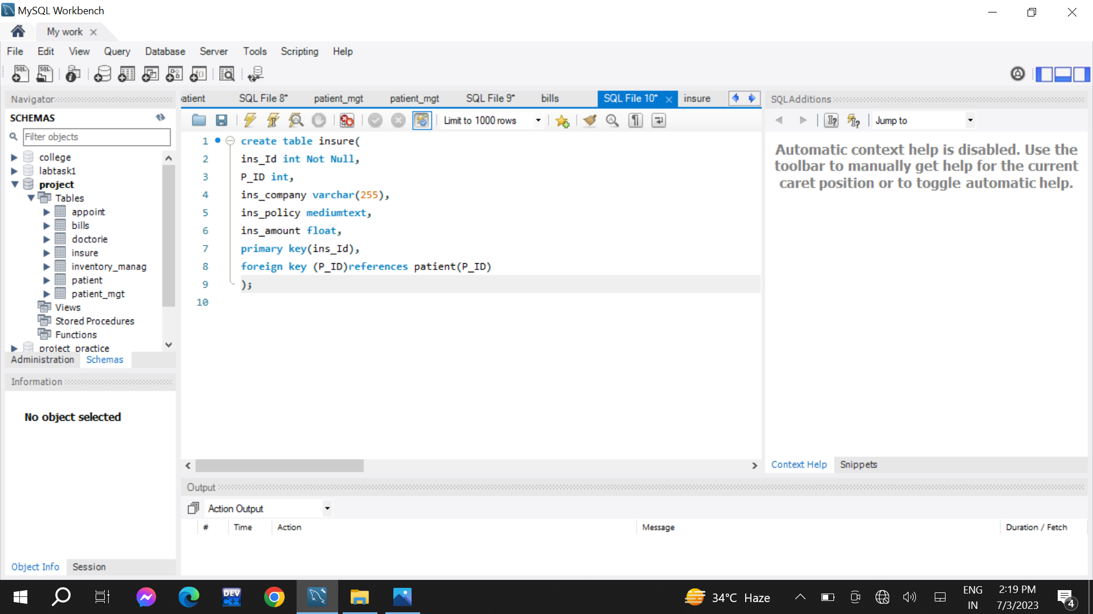

Doctor Table

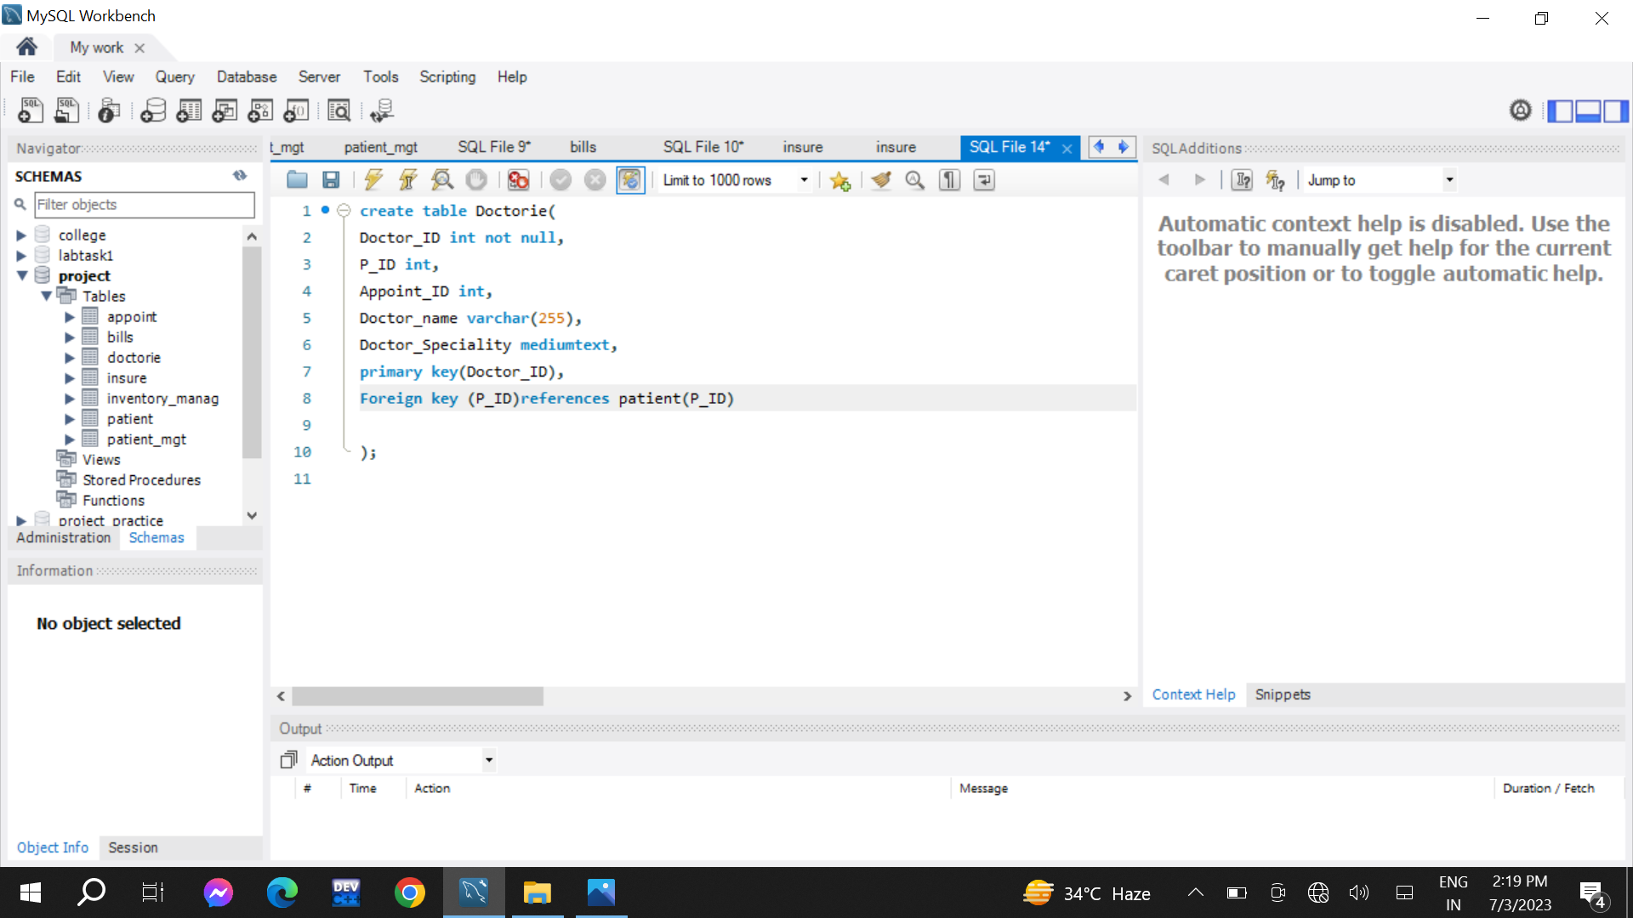

Appointment table

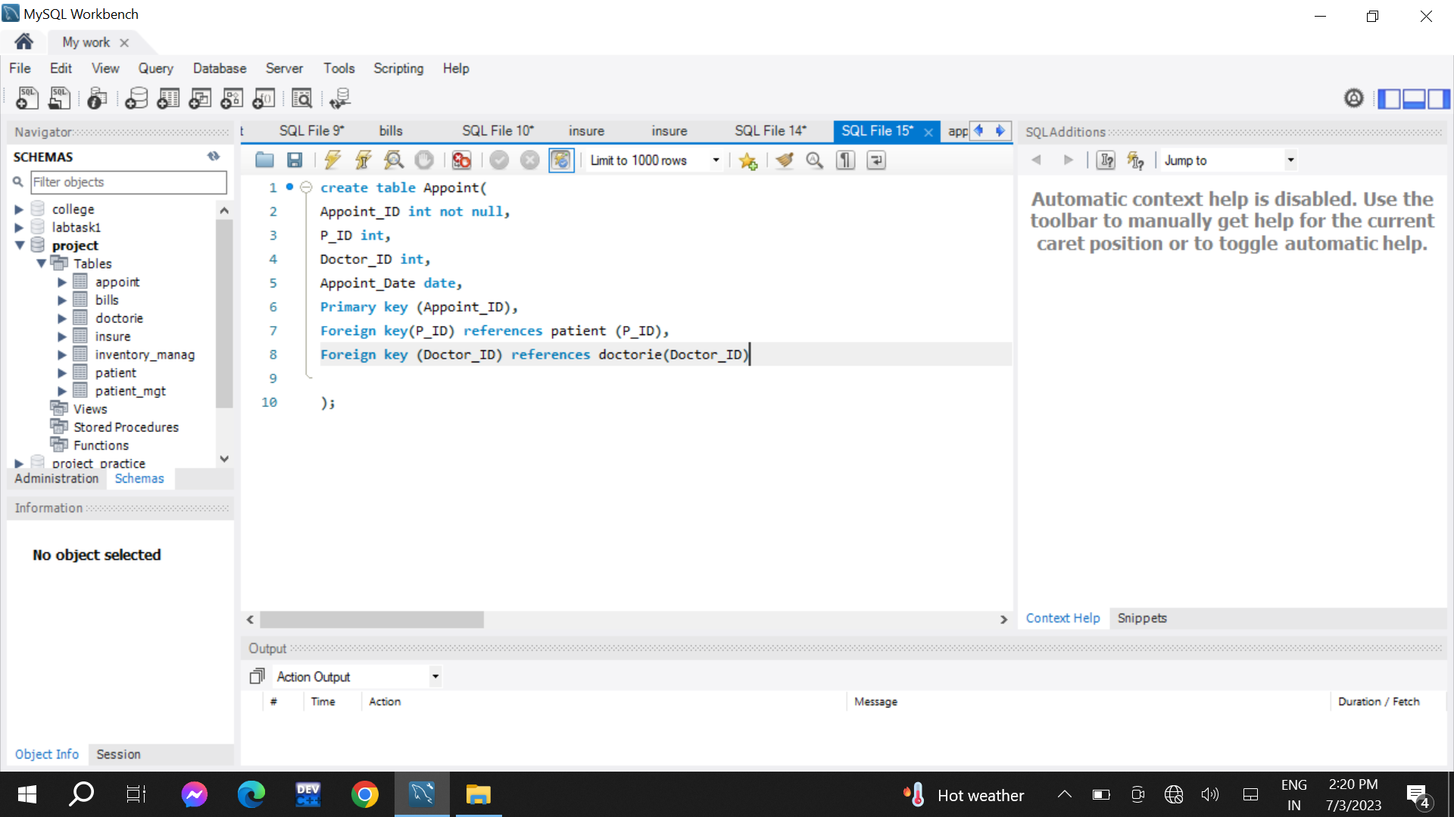

Inventory Management Table

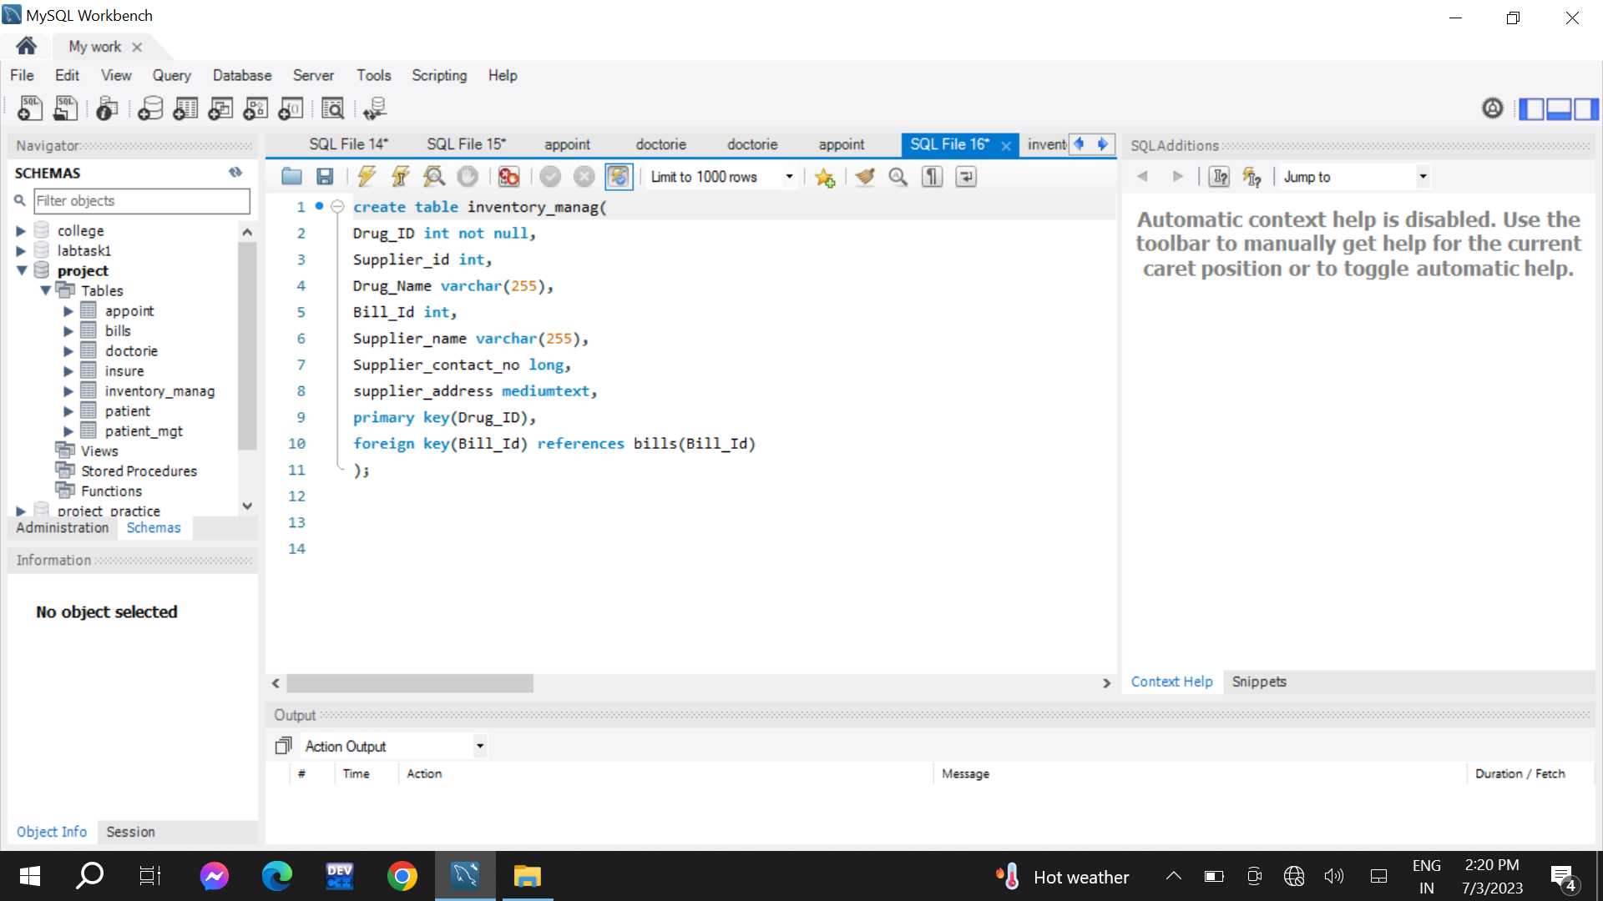

# Query: Retrieve All patients and their information

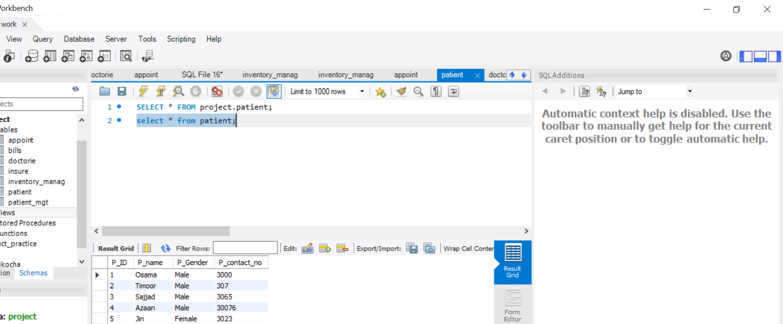

Query :Retrieve appointment schedule for particular day

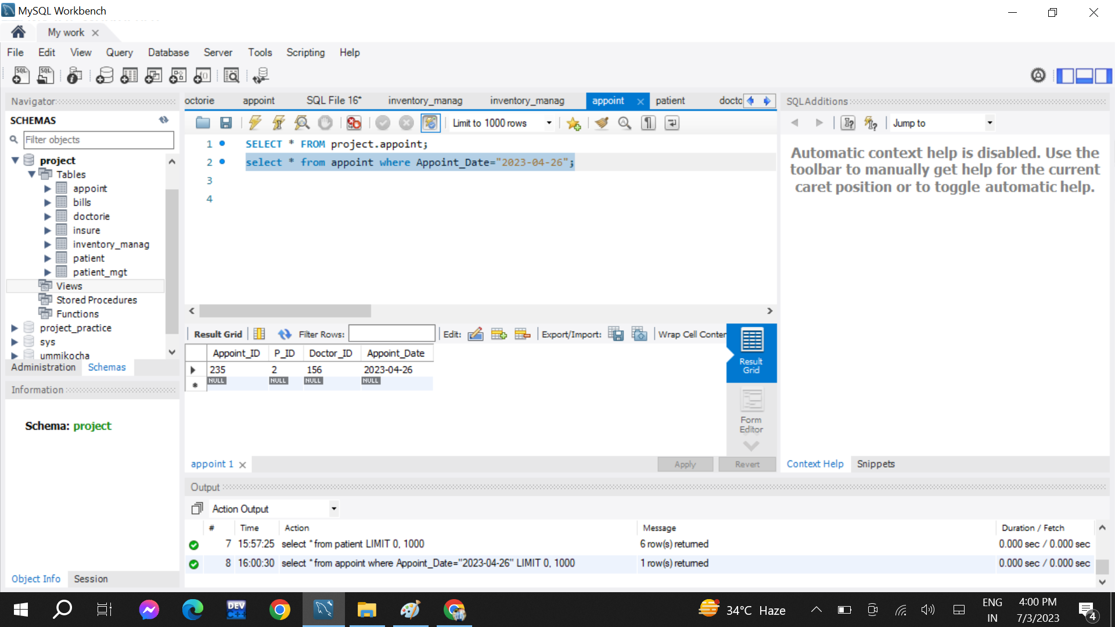

Retrieve total amount of payment paid by patient

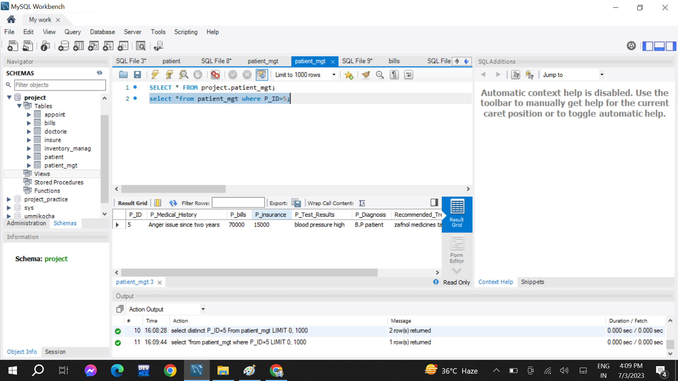

Retrieve Medical record for Particular Patient



Inserting new Medical Record

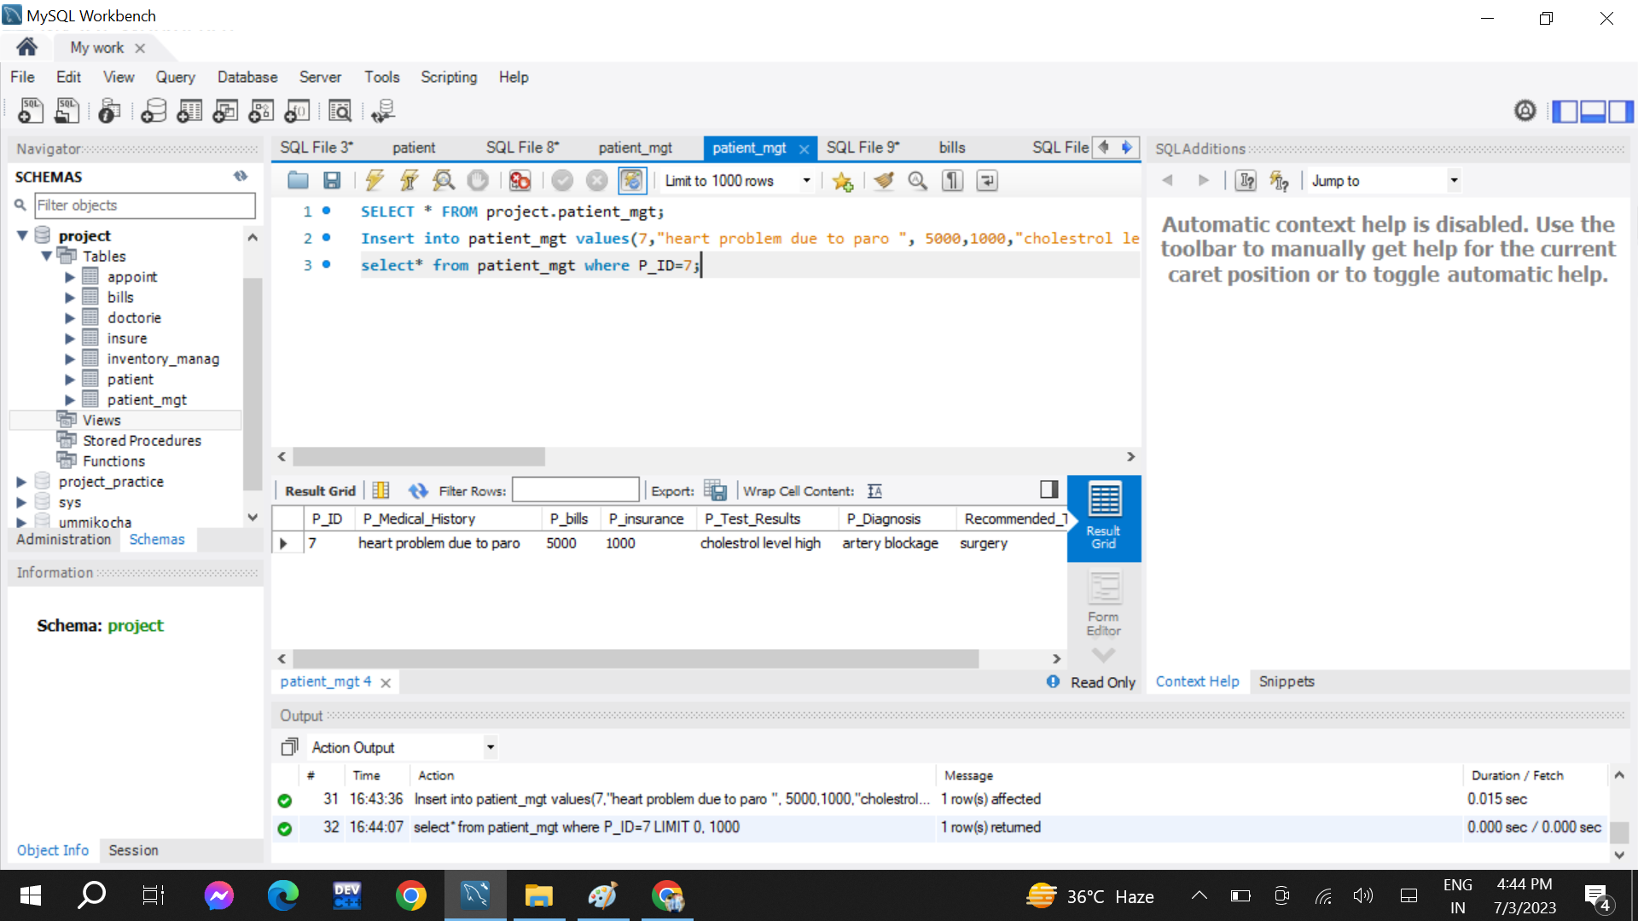

Delete Medical Record of Particular Patient

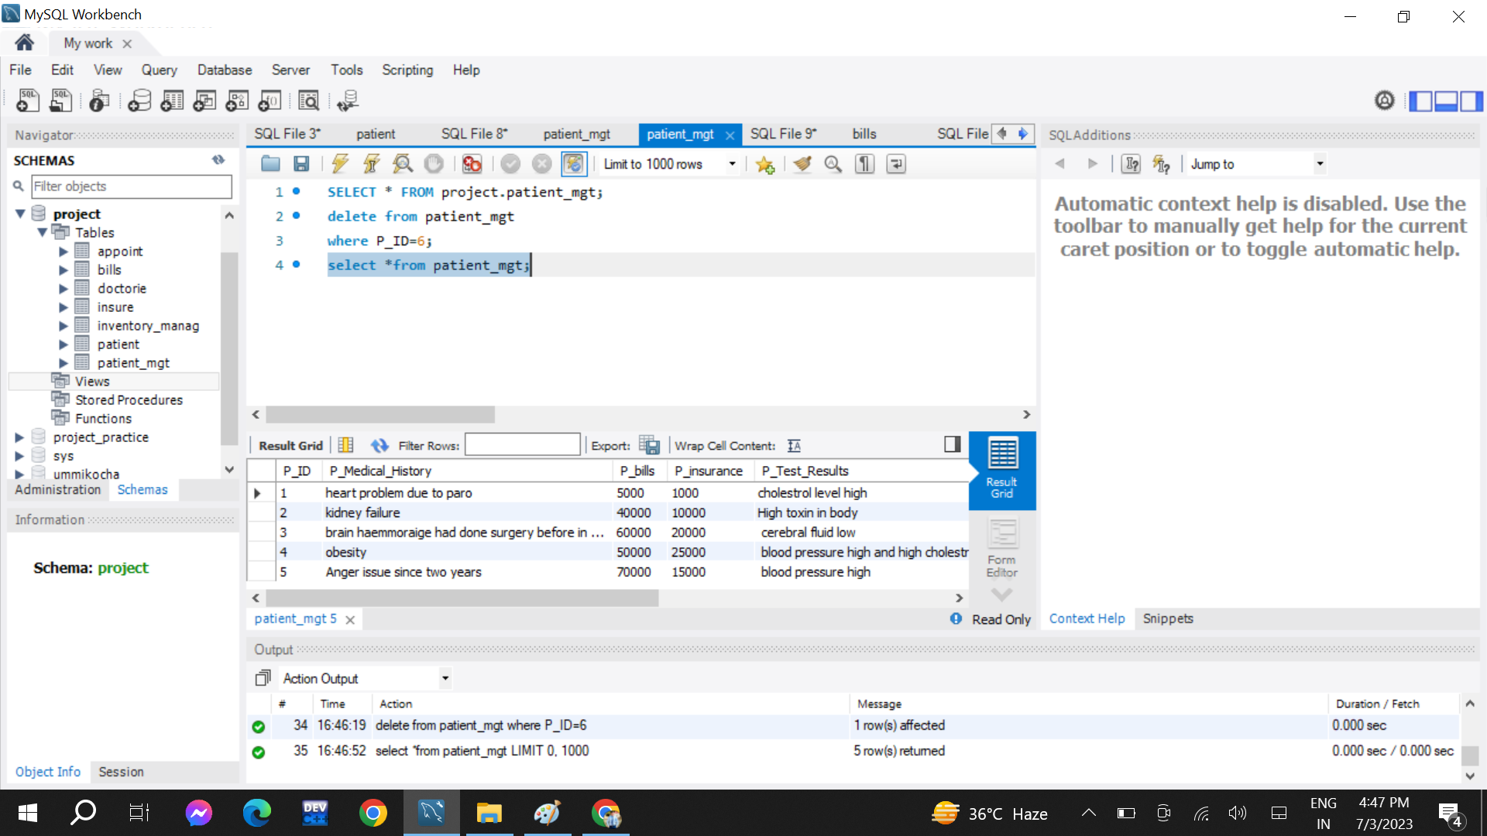

Retrieving All health care Professional with Their Speciality

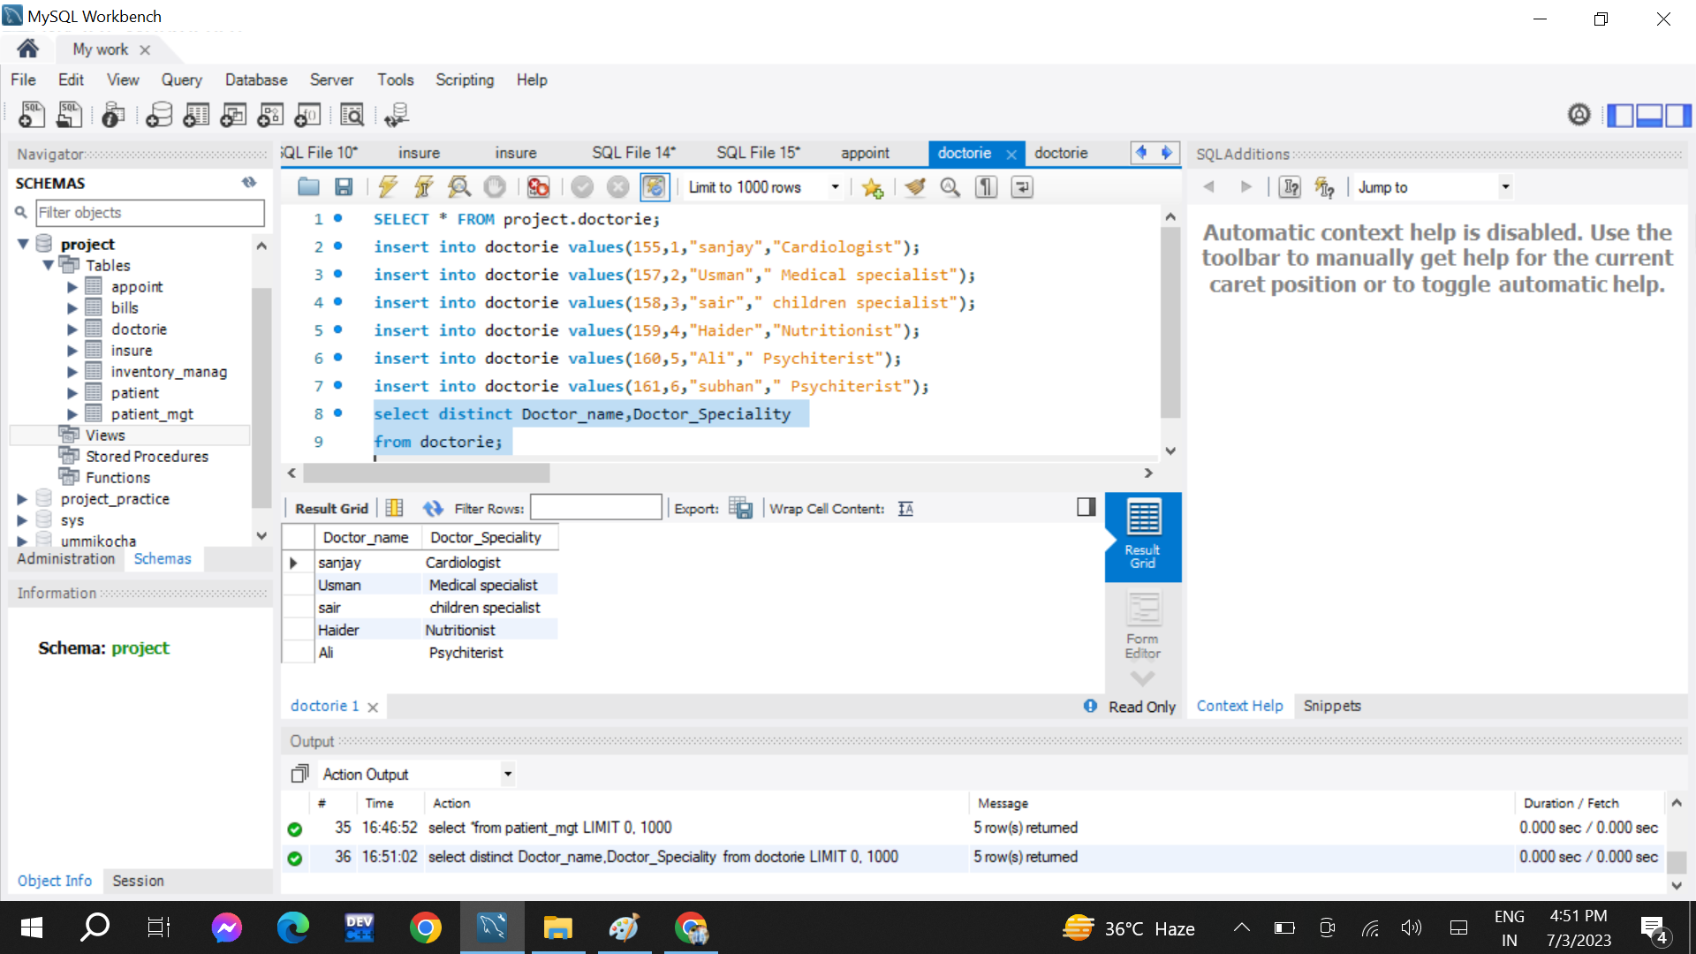

Retrieve Payments by All Patients

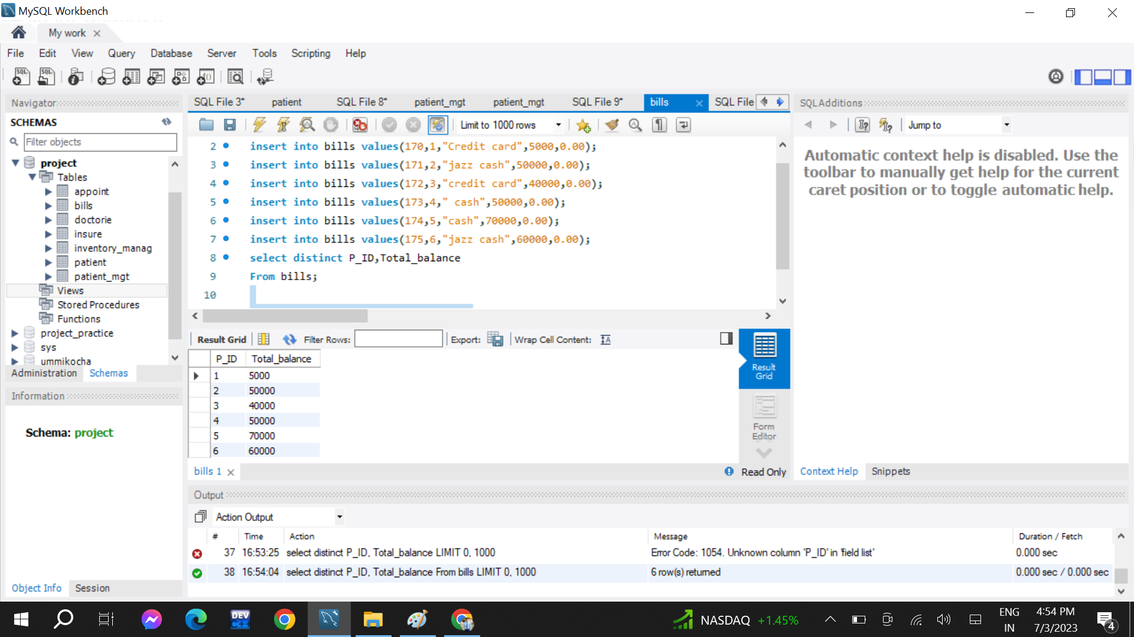

Retrieve All Appointments for Patient

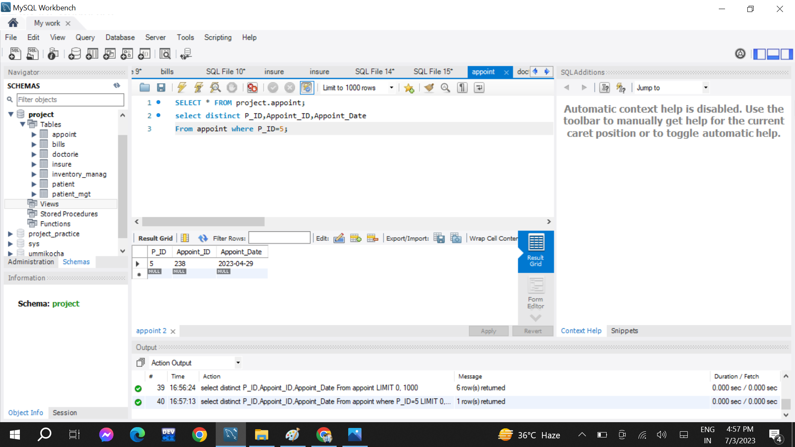

Retrieve The Particular diagnose of Patient

